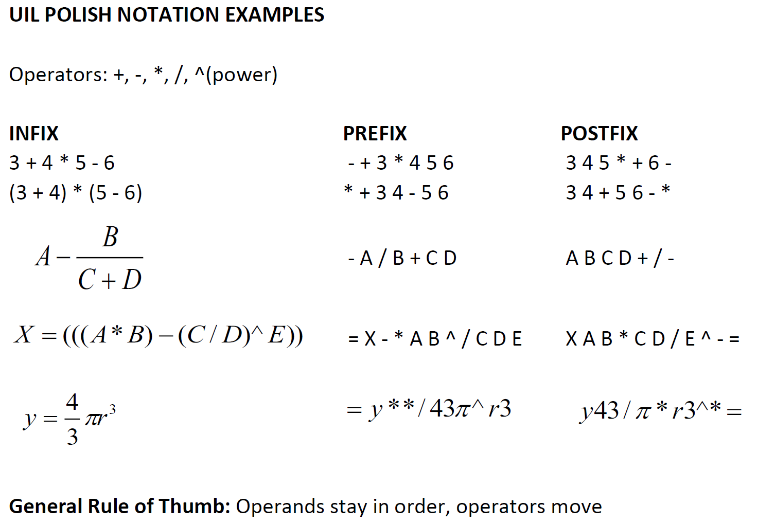

Infix to Postfix

Fully Parenthesized the Expression. An FPE has exactly one set of Parentheses enclosing each operator and its operands.

(A + B) * C – (D + E) / F (((A + B) * C) – ((D + E) / F))

Move each operator to the right of its operands and remove the parentheses:

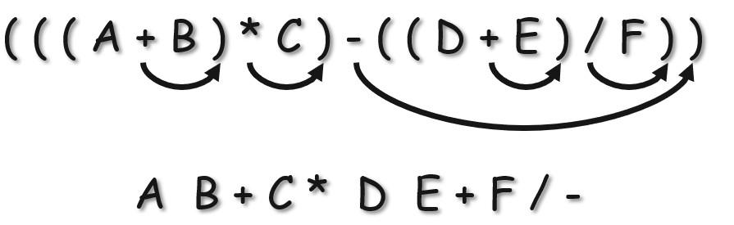



Important points

Only the operators move, never the operands.

Notice how in this example the addition operator is either before or between or after its operands, which are A and the product of B and C. In every notation A is before B and C. The operands don’t move, only the operator:

PREFIX | INFIX | POSTFIX
+ A * B C | A + B * C | A B C * +

Don't rewrite infix in normal math notation:

- Leave the operators and operands as they are.
- Leave an expression like 5 + -4 as is. Don't change it to 5 - 4.
- Leave (x + 2)/3 as is. Don't rewrite as $\frac{x+2}{3}$
- Don't rewrite 2 ^ 3 ^ 2 as $2^{3^{2}}$
Note that exponentiation is right associative, which means:
$2^{3^{2}}$ = 2 ^ 3 ^ 2 = 2 ^ (3 ^ 2) = $2^{(3^{2})}$ = $2^{9}$ = 512

Not: (2 ^ 3) ^ 2 = ${(2^{3})}^{2}$ = $8^{2}$ = 64

Prefix = PN = Polish Notation
Postfix = RPN = Reverse Polish Notation

